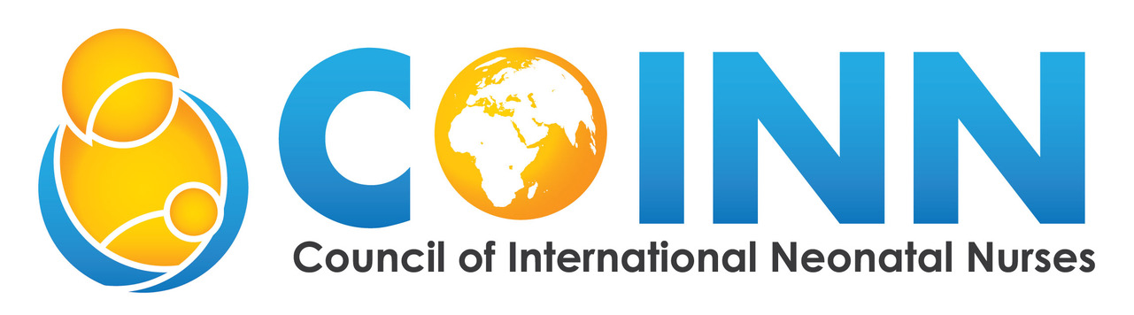
COINN Board of Directors Nomination Questions
Please answer the following questions (maximum two pages in total). Please attach your curriculum vitae (CV) or résumé with your nomination.

Name:

Position Nominated For:

Country:

Email Address:

Why are you interested in a COINN Board position?

What is your vision for COINN?

What activities could you undertake on behalf of COINN?

What is your involvement with neonatal nursing, your national association, or with COINN?

What experience do you have serving on national or international boards?

Nominations must be received by 30 June 2026.
Please send completed nominations and supporting documents to: ceo@coinnurses.org

